1. **Introduction :**
   1. **Project Summary :**

This is web based system to track progress and genuine work of each IDP/UDP project of the last year student.This system is useful to both administrator and students to manage their work efficiently. The main objective of this system is to provide all the features with the "interfaces that doesn't Scare it's Users. The system entiled “Project Review and Evaluation System” is to provide feasibility to student and professor.

* 1. **Objective & Scope :**
* This web based system provides facility to conduct project review online.
* The system allows Professors to view the profile of all student. The student submit the project detail via this system online.
* The system allow professors to accept, reject the project approval request online.
* The basic function of this system include registration, profile creation, guide allocation management, list of project, project tracking, request for NOC etc.
* Students does not need of going to any physical destination. They can approve definition of their project online and get answer by professor immediately.
* This website reduces the manual work, maintaining accuracy, increasing efficiency and saving time.
* . The system also have feature of tracking and evalution of the project.
  1. **Hardware-Software technology used :**

Front End tool : jsp, servlet,HTML,CSS,Javascript

Back End tool : My SQL,Apache Tomcat

Hardware configuration(minimum) : 512 MB RAM, Disk space : 40GB, Processor : intel Pentium or higher.

1. **System Analysis :**
   1. **Study of current system :**

In todays, students have to go college for their approval of project and give application for NOC letter. After that guide is allocated to student. Every time student has to go college for weekly progress report for submitting their guide. Guide will suggest them. if student take UDP project than they have to present college and must finish their daily work.

* 1. **Problem and weakness of current system :**

In current system, if little query aries about project than student has to go college. This is time consuming. Student can not get answer immediately. Request for NOC is also take one day. After take NOC, they have to submit in company. So this current system is not efficient.

* 1. **Requirement of new system :**

**Administrator Requirement :**

* Here administrator can perform overall operation of project management. Admin can add faculty and also able to delete faculty. The adsministrator is one who manipulate and maintains the whole system. He can enter into the system by entering login name and password and issue a valid ID for the user. He is also responsible for sending result to the email id provided by the user at the start of his/her registration.

**Faculty Requirement :**

* He/she can create project list for different languages. Faculty information like occupation of faculty, education of faculty, view project definition of description of project which is given by student. The faculty is responsible for approval of project, suggestion of any queries, guideline about project.

**Student Requirement :**

* Whenever new student is registered into website then it can be added in this module. this module is used to manage Student information. Student can give project definition and also view the result of guide about their project which is approved or not.
* Can do the member registration. After the registration, he will be issued with valid ID by the Administrator. The user can log into the system with this ID. After successfully login into the system, the user moves to the instruction web page where he will get instruction about their project.

**Project Tracking requirement :**

* Project tracking is useful to track the project. Project tracking can be done by reporting project status details like current work, future work, task allocation within particular time period.
  1. **Feasibility study :**
* Feasibility study is a process to check possibilities of system development. It is a method to check various different requirements and availability of financial &technical resources.
* There are three different ways feasibility can be tested as follows:
* **Technical Feasibility:**

My website is developing in JAVA language. And we are using Eclipse IDE for it, so technical development is feasible.

* **Operational Feasibility:**

Email System will be user friendly. And it will be meet all the Functional requirement which mention above.

* **Economical Feasibility:**

The software tools which are used in development are cost effective and easy to maintain.

1. **Project management :**
   1. **Project planning and scheduling :**

The first step to be taken in project management is project planning. There are five major activities that are performed in project planning.

1. Project estimation
2. Project scheduling
3. Risk analysis
4. Quality management planning
5. Change management planning

Project estimation begins with a description of the scope of project product. there are many useful technique for time and efford estimation.

* + 1. **Project development approach :**
* Our project follows the spiral model. Each and every stage modification is done.
* This model possess the iterative nature of prototyping model. This model gives efficient development of incremental versions of software. In this model, the software is developed in series of increments.
* The spiral model is divided into number of framework activities. These framework activities are denoted by task regions.
* Spiral model is realistic approach to development of large scale system and software.
  + 1. **Project plan & Scheduling representation :**

Project plan is a simple document useful for execution of project. In this plan, the risk analysis activities are described as follows:

|  |  |  |
| --- | --- | --- |
| **Risk table** | | |
| Risk | Category | Probability |
| Is the skilled faculty available | faculty | 70% |
| Have faculty provide good suggestion to student | faculty | 80% |
| Will technology meet the expection | technology | 90% |
| How much amount of reused software is required | Project size | 60% |

While scheduling the project, the manager has to estimate the time and resources of the project. All the activities in the project must be arranged in coherent sequence. The schedule must be continually updated because some uncertain problem may occur during project life cycle.

**3.1.3. Roles and Responsibilities :**

**Admin :**

Admin should maintain the database properly. He should provide id to access the system to student must be validate. So student would not face any difficulties. Also admin validate the user when student logged in. he can see whole process.

**Faculty :**

Faculty should provide sufficient guideline to student. He can see the progress of student’s weekly report. Faculty should rply them if needed. Also they send updated information about student’s project.

**Student :**

Student should finish their daily work as per faculty’s instruction. They should send weekly report to their guide.

**3.2 Risk Management :**

**3.2.1 Risk Analysis :**

The project planner, manager performs following steps to perform following steps for risk analysis :

* Establish a scale that indicates the probability of risk being real.
* Enlist the consequence of the risk.
* Estimate the impact of the risk on the project and product.
* Maintain the overall accuracy of the risk projection in order to have clear understanding of the software that is to be built.

**3.2.2 Risk Planning :**

In risk planning, various risks are enlisted. The risk planning specifies the risk control tasks that will be performed for the project.

The risk control task enlisted in the risk plan help in monitoring the overall risk of the project. The risk planning resolves around the testing and reviews.

**3.2.3 Risk Identification :**

Risk identification means in which situation risk is occure. In this project, when user does not enter right login id or password than he or she can not access system. Admin must maintain the database. When faculty does not know about project definition than he can not guide the student.

1. **System Modeling :**
   1. **Dataflow Diagrams :**



**Fig. Context level diagram**



**Fig.Level-1 DFD**



**Fig.Level-2 DFD**

* 1. **Use case diagram :**



**Use case Description :**

1)use case : registration

Summary : admin,student and faculty registered themselves.

Actors : admin, student, faculty

Description : every user must register themselves to access the system .

2) use case : view and edit profile

Summary : admin view and edit the profile of student.

Actor : admin

Description : admin can view the profile and edit them if needed.

3) use case : create team and view team detail

Summary : student create team up to 10 students.

Actor : student

Description : student can make a team and every student of team can see the

Details.

4) use case : Approval of project

Summary : faculty approve the project.

Actor : faculty

Description : faculty approve the project and if definition is not proper than also

Reject it.

5) use case : submit project detail

Summary : student submit the project detail to faculty.

Actor : student

Description : student should submit their project detail to their guide before

Project starts.

6) use case : request for NOC

Summary : student request for NOC to their guide.

Actor : student

Description : student should request for NOC.

**4.3 Activity diagram :**

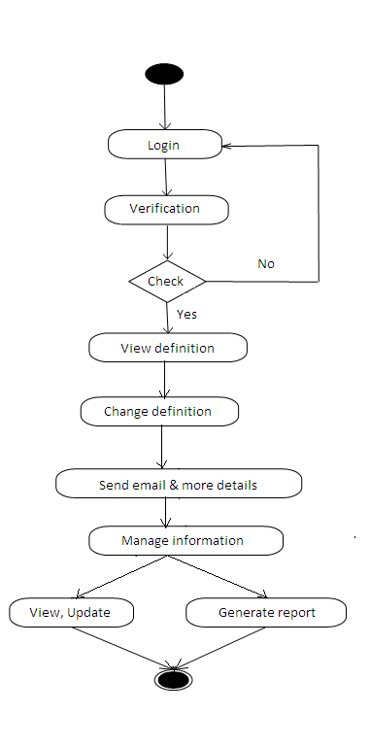

**Fig.Admin activity**

**4.4 sequence diagram :**



**4.5 State Transition diagram :**

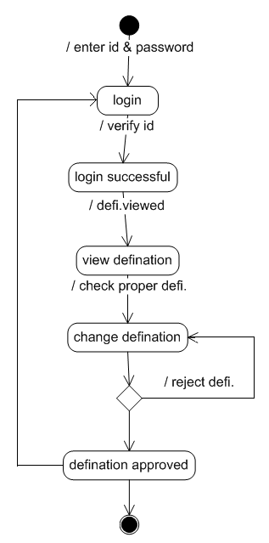

**4.6 Class diagram :**

**5.Data modeling and design :**

* 1. **Data Dictionary :**

**1)User Table :**

|  |  |
| --- | --- |
| Constraint | Fieldname |
| Primary key | User_id |
| Foreign key | Branch_id |

|  |  |  |  |  |
| --- | --- | --- | --- | --- |
| Sr no. | Field name | Data type | Constraint | Description |
| 1 | User_id | int | Primary key | User id |
| 2 | Branch_id | int | Foreign key | Branc id |
| 3 | Enrollment | varchar | Unique | Enrollment |
| 4 | Password | varchar | Not null | Password |
| 5 | Email | varchar | Not null | Email |
| 6 | Team_id | varchar | Not null | Team id |
| 7 | Firstname | varchar | Not null | Firstname |
| 8 | Middlename | varchar | Not null | Middlename |
| 9 | Lastname | varchar | Not null | Lastname |
| 10 | Birthdate | varchar | Not null | Birthdate |
| 11 | Gender | varchar | Not null | Gender |
| 12 | Address | varchar | Not null | Address |
| 13 | Contect no. | varchar | Not null | Contect no. |
| 14 | Passout | varchar | Not null | Passout |

**2) Branch Table :**

|  |  |
| --- | --- |
| Constraint | Fieldname |
| branch_id | Primary key |

|  |  |  |  |  |
| --- | --- | --- | --- | --- |
| Sr no. | Field name | Data type | Constraint | Description |
| 1 | branch_id | int | Primary key | branch id |
| 2 | branch_name | varchar | Not null | branch name |
| 3 | branch_code | varchar | Not null | branch code |

**3)Faculty table :**

|  |  |
| --- | --- |
| Constraint | Fieldname |
| faculty_id | Primary key |
| branch_id | foreign key |

|  |  |  |  |  |
| --- | --- | --- | --- | --- |
| Sr no. | Field name | Data type | Constraint | Description |
| 1 | faculty_id | int | Primary key | faculty id |
| 2 | branch_id | int | Foreign key | branch id |
| 3 | Username | Varchar | Unique | username |
| 4 | Password | Varchar | Not null | password |
| 5 | Emailid | varchar | Not null | Emailid |
| 6 | mobilenumber | varchar | Not null | Mobilenumber |

**4) Team Table :**

|  |  |
| --- | --- |
| Constraint | Fieldname |
| team_id | Primary key |
| faculty_id | foreign key |

|  |  |  |  |  |
| --- | --- | --- | --- | --- |
| Sr no. | Field name | Data type | Constraint | Description |
| 1 | team_id | varchar | Primary key | Team id |
| 2 | faculty_id | varchar | Foreign key | Faculty id |
| 3 | Createdby | varchar | Not null | Createdby |
| 4 | member1 | varchar | Not null | member1 |
| 5 | member2 | varchar | Not null | member2 |
| 6 | member3 | varchar | Not null | member3 |
| 7 | creationdate | date | Not null | Creationdate |

**5) Project Table :**

|  |  |
| --- | --- |
| Constraint | Fieldname |
| project_id | Primary key |
| team_id | foreign key |

|  |  |  |  |  |
| --- | --- | --- | --- | --- |
| Sr no. | Field name | Data type | Constraint | description |
| 1 | project_id | int | Primary key | Project id |
| 2 | team_id | varchar | Foreign key | Team id |
| 3 | Projecttitle | varchar | Not null | projecttitle |
| 4 | projectdescription | text | Not null | projectdescription |
| 5 | projecttechnology | text | Not null | projecttechnology |
| 6 | Projecttype | varchar | Not null | projecttype |
| 7 | companyname | varchar | Not null | companyname |
| 8 | Guidename | varchar | Not null | guidename |
| 9 | guidecontact | varchar | Not null | guidecontact |
| 10 | Guideemail | varchar | Not null | guideemail |
| 11 | Status | varchar | Not null | status |
| 12 | creationdate | varchar | Not null | creationdate |

**6) Forum Table :**

|  |  |
| --- | --- |
| Constraint | Fieldname |
| forum_id | Primary key |

|  |  |  |  |  |
| --- | --- | --- | --- | --- |
| Sr no. | Field name | Data type | constraint | Description |
| 1 | forum_id | int | Primary key | forum id |
| 2 | question | varchar | Not null | Question |
| 3 | user_id | int | Not null | user id |
| 4 | creationdate | varchar | Not null | Creationdate |

**7) Forumcomment Table:**

|  |  |
| --- | --- |
| Constraint | Fieldname |
| comment_id | Primary key |

|  |  |  |  |  |
| --- | --- | --- | --- | --- |
| Sr no. | Field name | Data type | constraint | Description |
| 1 | comment_id | int | Primary key | comment_id |
| 2 | Comment | varchar | Not null | Comment |
| 3 | user_id | int | Not null | user_id |
| 4 | Creationdate | varchar | Not null | creationdate |
| 5 | forum_id | varchar | Not null | forum_id |

**8) NOC Table:**

|  |  |
| --- | --- |
| Constraint | Fieldname |
| Id | Primary key |

|  |  |  |  |  |
| --- | --- | --- | --- | --- |
| Sr no. | Field name | Data type | constraint | description |
| 1 | Id | int | Primary key | Id |
| 2 | user_id | Int | Not null | user_id |
| 3 | faculty_id | int | Not null | faculty_id |
| 4 | Status | varchar | Not null | Status |
| 5 | creationdate | varchar | Not null | creationdate |

* 1. **Database Relationship Diagram :**

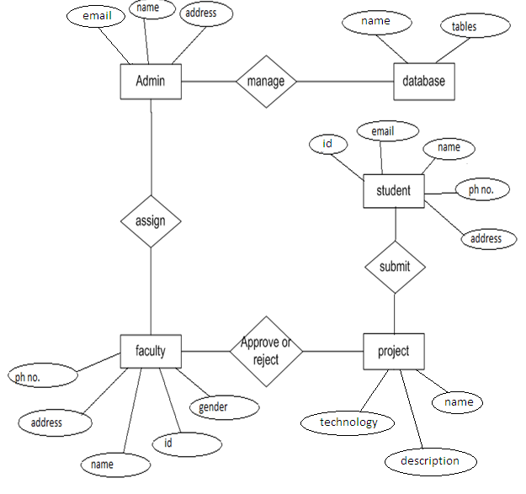

**5.3Input/Output interface design :**

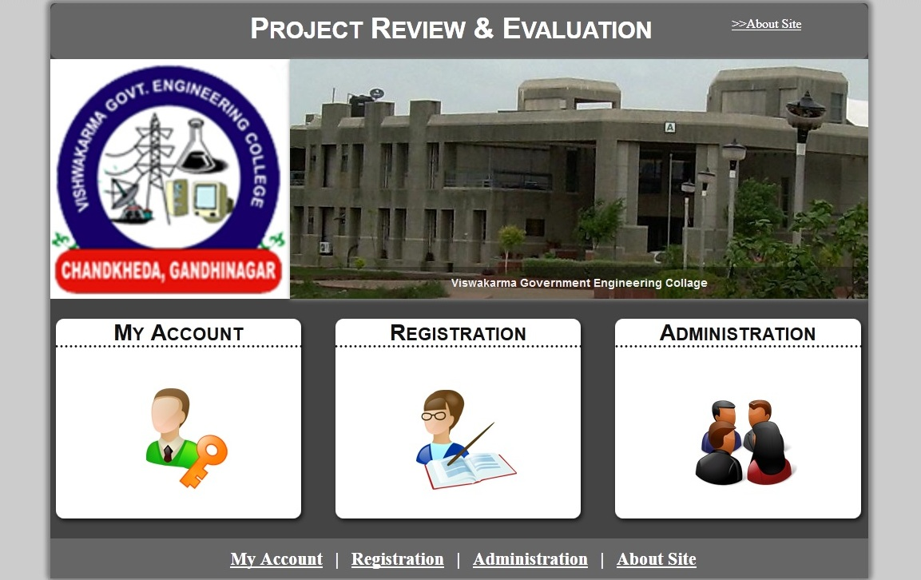**Home.jsp**

**user.jsp**

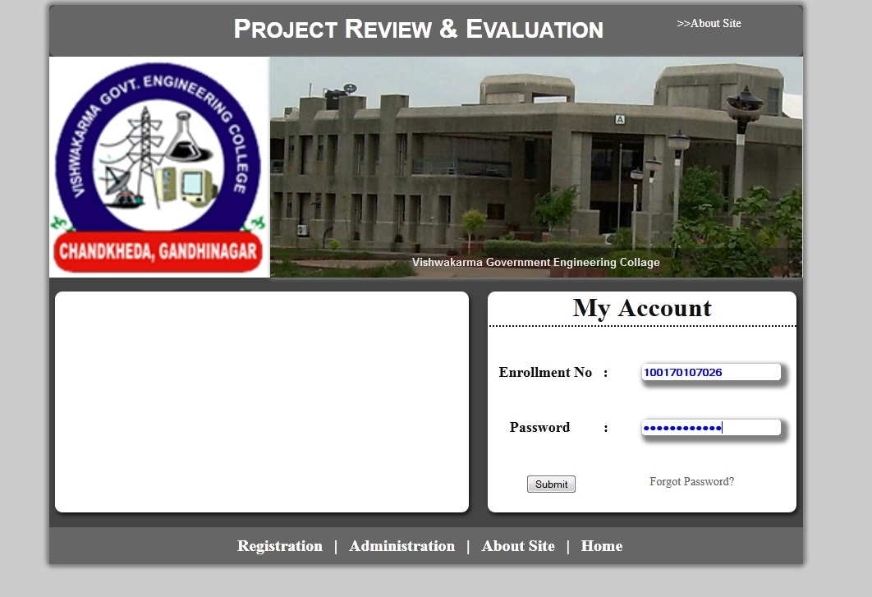

**Viewprofile.jsp**

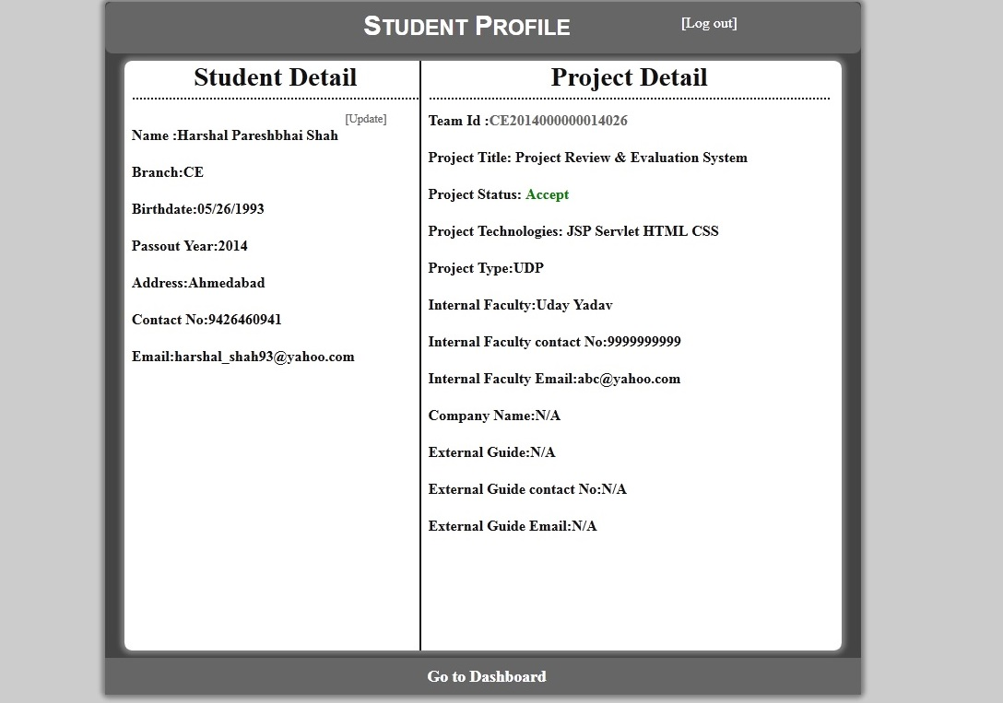

**Studentdash.jsp**

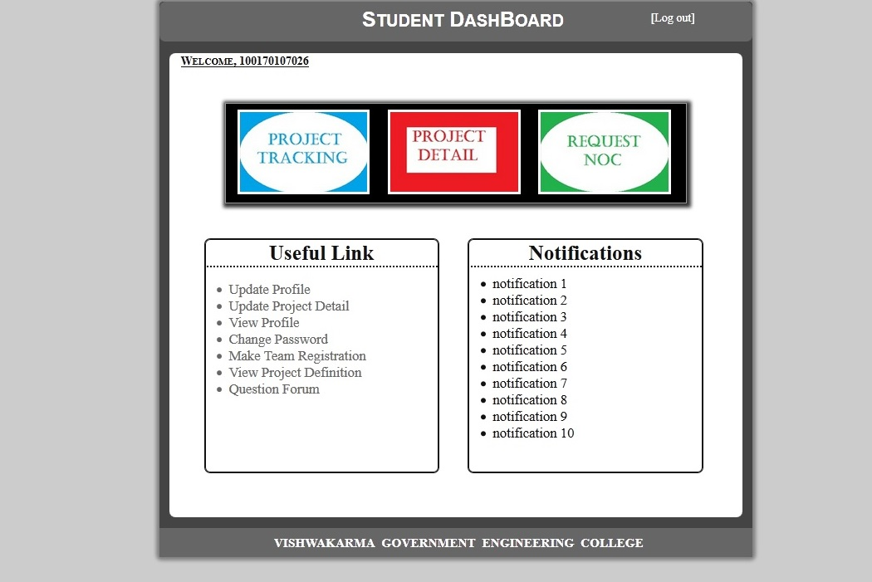

**updateprofile.jsp**

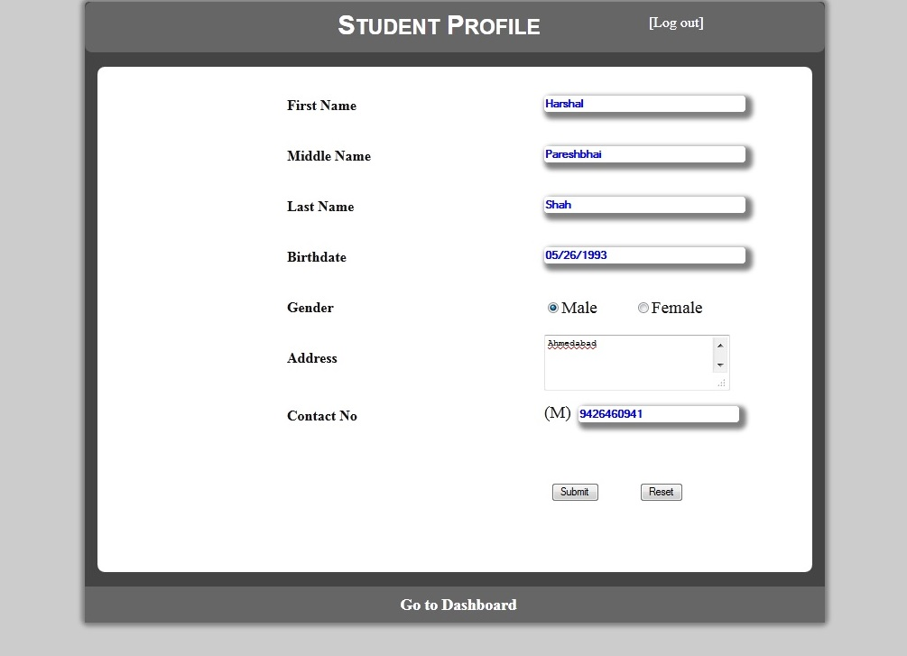

**questioforum.jsp**

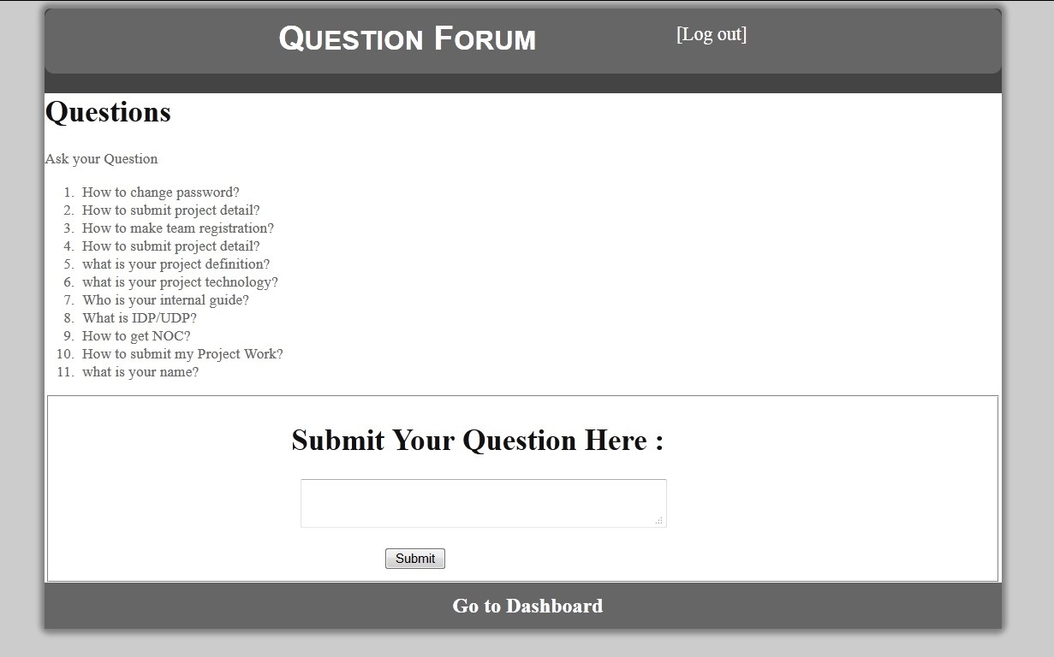

**registerteam.jsp**

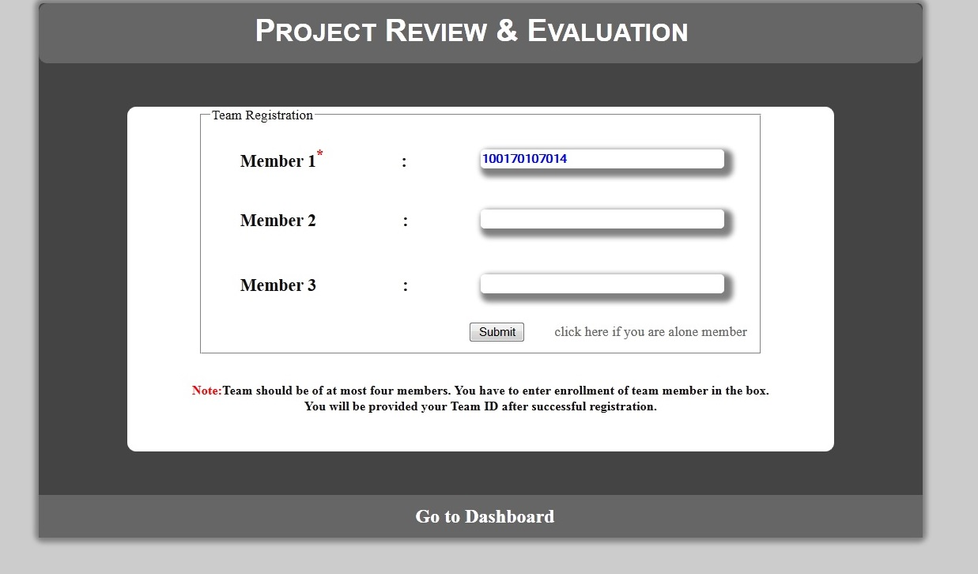

**6. Testing :**

**6.1 Test case :**

|  |  |  |  |
| --- | --- | --- | --- |
| **#** | **Summery** | **Pre_Condition** | **Post_Condition** |
| TC1 | User name is wrong | User name,Password | Re-enter the detail |
| TC2 | Password is wrong | User name,Password | Re-enter the detail |
| TC3 | User name & password are wrong | User name,Password | Re-enter the detail |
| TC4 | Max. no of attempts allowed | Three time consecutively user name | Account will lock |
| TC5 | Password strength validity | Eg.ABCDEF  (contain min. 6 characters,a-z,A-Z,0-9,special character) | Invalid |
| TC6 | If user is already exist and attamp to register | User name, password,re_enter password,email,passout year | Enrollment already exist |
| TC7 | If user is not exist and attamp to login | User name, Password | User does not exist |
| TC8 | If user already registerd in a team member and tries to register | Member1,member2,member3 | User already registerd with team |
| TC9 | Request for NOC | Fill detail | Profile is not completed. To get your NOC, do fill your profile. |

**7. Future enhancement :**

* Blog facility for inter communication between students and also between students and faculty advisor.
* Seminar management facilty along with project.
* Faculty can do online assessment of student project.
* Student can report their work periodically.

**8. Conclusion :**

* The project enabled us to understand all the design patterns thoroughly.
* Various techniques like use case analysis, state machine, DFD, activity diagram are helpful in prototyping software design.
* The project may use various tools of word and visio to improve efficiency of designing project.

**9. Bibliography and References :**

* [www.wikipedia.com](http://www.wikipedia.com)
* Software Engineering : A Practitioner's Approach, TMH

[ byPressman R.S.]